Genetics
Lesson 2
- Calculate the phenotypic ratio of a cross between a female carrier for red green colour blindness and a normal vision male.

- Haemophilia is a sex-linked trait where X^{H} gives normal blood clotting and is dominant to the haemophilia allele X^{h}.
a. Give the genotypes of
1) a woman with normal blood clotting whose father had haemophilia
2) a normal man whose father had haemophilia.
b. What is the probability that a mating between these two individuals will produce a child, regardless of sex, that has haemophilia?

c. If this couple has a daughter, what is the probability that the daughter will be a carrier of the haemophilia trait? What is the probability a daughter would have haemophilia?

d. If this couple has a son, what is the probability he will have haemophilia?

- For the genotypes below state what blood group they would be:
  - I^{A} I^{A}
  - I^{B} I^{B}
  - I^{A} I^{B}
  - I^{A} I^{O}
  - I^{B} I^{O}
  - I^{O} I^{O}

- Complete the following crosses:
Parents: blood group O and blood group AB

Parents: blood group A and blood group B (both heterozygous with the I^{O} allele)

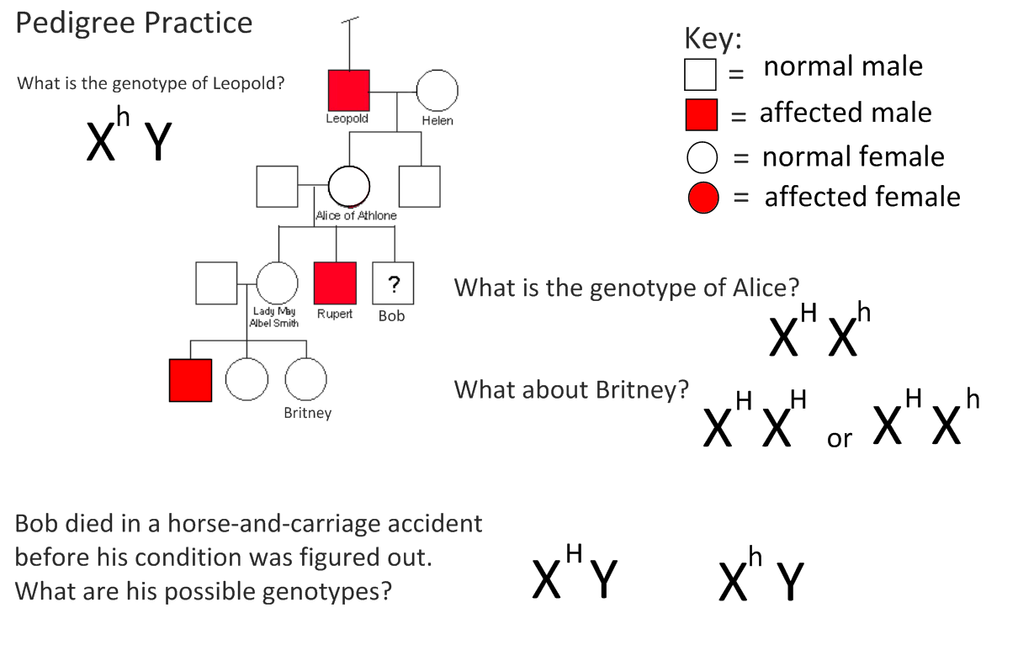
Genetics
Lesson 2
- Calculate the phenotypic ratio of a cross between a female carrier for red green colour blindness and a normal vision male.

Phenotypes :
 | X^{B} | X^{b}
X^{B} | X^{B} X^{B} | X^{b} X^{B}
Y | X^{B} Y | X^{b} Y
Normal female (carrier) x Normal male
Genotypes : X^{B}X^{b} x X^{B}Y

Gametes X^{B} X^{b} X^{B} Y

Female normal vision 50%
Male normal vision 25%
Male colour blind 25%

- Haemophilia is a sex-linked trait where X^{H} gives normal blood clotting and is dominant to the haemophilia allele X^{h}.
a. Give the genotypes of
1) a woman with normal blood clotting whose father had haemophilia X^{H}X^{h}
2) a normal man whose father had haemophilia. X^{H}Y
 | X^{H} | X^{h}
X^{H} | X^{H} X^{H} | X^{H} X^{h}
Y | X^{H}Y | X^{h}Y
b. What is the probability that a mating between these two individuals will produce a child, regardless of sex, that has haemophilia?

P = 25%

c. If this couple has a daughter, what is the probability that the daughter will be a carrier of the haemophilia trait? What is the probability a daughter would have haemophilia?
Carrier P= 0.5,
Haemophiliac P = o
d. If this couple has a son, what is the probability he will have haemophilia?
Haemophiliac son P =0.5

- For the genotypes below state what blood group they would be:
Blood group A
Blood group B
Blood group AB
Blood group A
Blood group B
Blood group O
  - I^{A} I^{A}
  - I^{B} I^{B}
  - I^{A} I^{B}
  - I^{A} I^{O}
  - I^{B} I^{O}
  - I^{O} I^{O}

- Complete the following crosses:
 | Iº | Iº
I^{B} | Iº I^{B} | Iº I^{B}
I^{A} | Iº I^{A} | Iº I^{A}
- Parents: blood group O and blood group AB
Blood group B 50%
Blood group A 50%

Parents: blood group A and blood group B (both heterozygous with the I^{O} allele)
 | I^{A} | Iº
I^{B} | I^{A} I^{B} | Iº I^{B}
Iº | I^{A} Iº | Iº Iº
Blood group AB 25%
Blood group A 25%
Blood group B 25%
Blood group O 25%

