GCSE
“We are what we repeatedly do. Excellence, therefore, is not an act but a habit”
Core Gateway Science B
B1: Understanding Organisms

Unit |  | Page | Completed By
1a | Fitness and Health | 4
1b | Human Health and Diet | 6
1c | Staying Healthy | 8
1d | The Nervous System | 12
1e | Drugs and You | 15
1f | Staying in Balance | 17
1g | Controlling Plant Growth | 19
1h | Variation and Inheritance | 20
Use the activities and past exam questions in this booklet to plan and support your revision ready for the B1C1P1 science exam.
REVISION WEBSITE – The follow website is available for you to use to support you revision and help you answer the exam questions in this revision guide

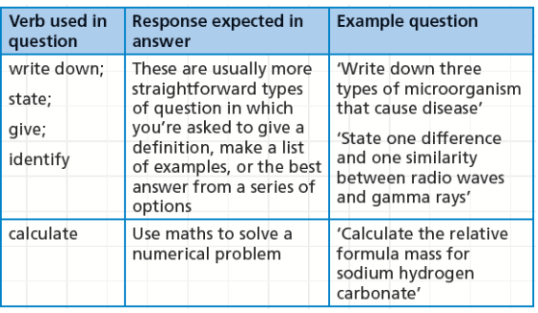
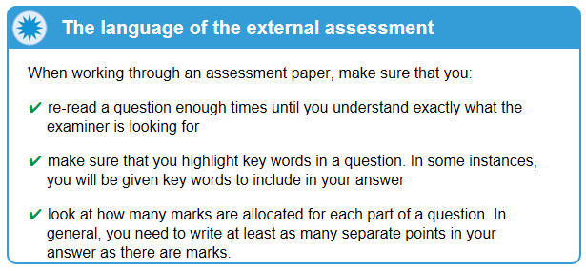
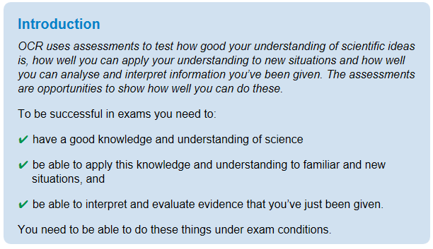
B1a: Fitness and Health
Grade E Grade C Grade A
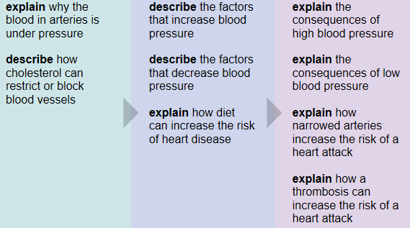
Key Information
Fitness is the ability to do physical activity. Healthy is being free from disease.

When measuring blood pressure you get two measurements. The maximum pressure (when the heart beats) called the systolic pressure, and the lowest pressure (in between heart beats) called the diastolic pressure.
Revision Ideas
- Make some revision cards with key term definitions for the following words – Systolic, Diastolic, Arteries, Fitness, Health, Stamina, Agility, Cholesterol
- Design a set of tests to measure someone’s fitness. Think about all the ways we can measure fitness.

QWC Question (6 marks)
When answering a QWC question remember the following points: Use correct science vocabulary, organise ideas, avoid using “it”, and write in full sentences. You also need to try and keep you answer relevant to the question. A good way to do all this is to write out important key vocabulary and then use them to structure your answer. Underlining them will help you keep track and highlight to the examiner your good use of key terms,
Question – This question is about heart disease
Daniels family want to keep fit and healthy. They know that heart disease is the main cause of death in the UK. Explain what factors can lead to a higher risk of heart disease and describe what can be done to reduce the risks (6marks)
Important words list
Smoking
Blood pressure
Salt
Diet
Saturated Fats
Blood flow
Cholesterol
Plaque
Heart Attack

B1b: Human Health and Diet
Grade E Grade C Grade A
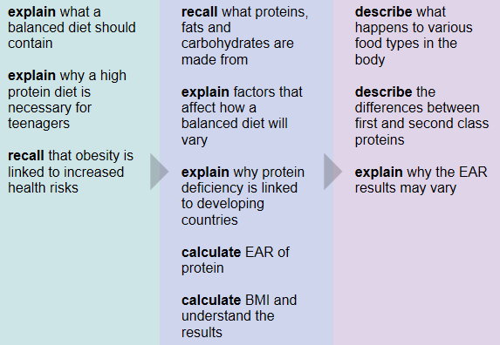
Key Information
Food provides the energy and materials needed by living things. Carbohydrates and fats are high- energy sources. Protein is needed for growth and repair. Protein deficiency leads to diseases such as kwashiorkor.
Revision Ideas
- Create an information leaflet on eating a balanced healthy diet. What should people eat and why. Is it the same for everyone? Include information for people who might eat specialised diets.
- Create a card sort for the simple chemicals carbohydrates, proteins and fats are made up of.
QWC Question (6 marks)
When answering a QWC question remember the following points: Use correct science vocabulary, organise ideas, avoid using “it”, and write in full sentences. You also need to try and keep you answer relevant to the question. A good way to do all this is to write out important key vocabulary and then use them to structure your answer. Underlining them will help you keep track and highlight to the examiner your good use of key terms,
Question – This question is human health and diet
Famines occur in countries that are overpopulated and where crops have failed. Describe the importance of protein in a person’s diet and explain what could happen if there is a lack of protein. (6marks)
Important words list
Energy Supply
Starvation
Growth and repair
Kwashiorkor
Swollen bellies
Famines
Water
EAR
B1c: Staying Healthy
Grade E Grade C Grade A
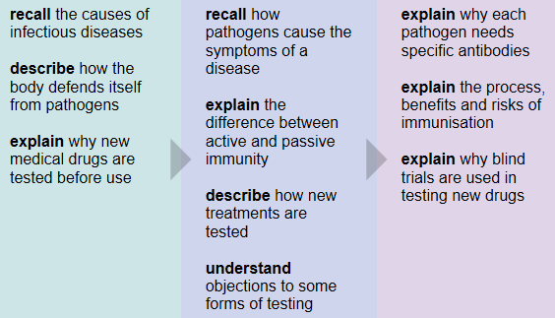
Key Information
Pathogens are microorganisms that cause disease. The body has several defence mechanisms to prevent pathogens from entering the body and reproducing there.

The immune system can destroy pathogens that manage to enter the body. New medical treatments and drugs must be tested before their use.
Revision Ideas
- Create revision cards on the different types of pathogens.
- Research how malaria is spread. Produce a flow diagram to show the spread of malaria.
QWC Question (6 marks)
When answering a QWC question remember the following points: Use correct science vocabulary, organise ideas, avoid using “it”, and write in full sentences. You also need to try and keep you answer relevant to the question. A good way to do all this is to write out important key vocabulary and then use them to structure your answer. Underlining them will help you keep track and highlight to the examiner your good use of key terms,
Question – This question is fighting disease.
Ben feels hot. His mum takes his temperature and it is high. His body is fighting an infection. Explain how the body fights against bacteria and describe how his body develops an active immunity against this disease. (6marks)
Important words list
White blood cells
Engulf
Antibodies
Pathogen
Immune system
Bacteria
Active Immunity
Antigens
Recognise
B1d: The Nervous System
Grade E Grade C Grade A
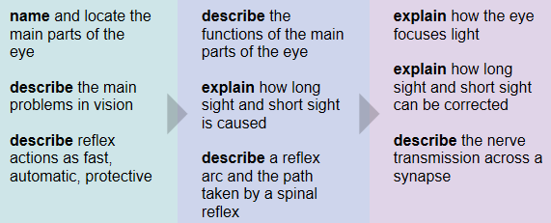
Key Information
The sense organs contain receptors that are sensitive to stimuli.

The nervous system consists of the central nervous system - brain and spinal cord -and peripheral nerves. Nerve impulses travel through the axons of neurones - nerve cells. Reflex actions are fast, automatic and protective responses.

Human vision is binocular, which gives us a good perception of depth. Vision defects include short-sightedness, long-sightedness and colour blindness.

Revision Ideas
- Draw and label a diagram of the eye, describing the function of each part
- Draw and label a diagram of a reflex arc. Mount it on card and make it into a jigsaw by cutting it into different shapes. Practice putting it back together.

QWC Question (6 marks)
When answering a QWC question remember the following points: Use correct science vocabulary, organise ideas, avoid using “it”, and write in full sentences. You also need to try and keep you answer relevant to the question. A good way to do all this is to write out important key vocabulary and then use them to structure your answer. Underlining them will help you keep track and highlight to the examiner your good use of key terms,
Question – This question is about reflexes.
David puts his hand on a extremely hot plate. He immediately pulls his hand away. This is a reflex action. Describe the important features of a reflex action, and explain the stages involved in the reflex action. (6marks)
Important words list
Stimulus
Receptor
Sensory Neurone
Relay Neurone
Motor Neurone
Effector
Response
Fast
Without thinking
B1e: Drugs and You
Grade E Grade C Grade A
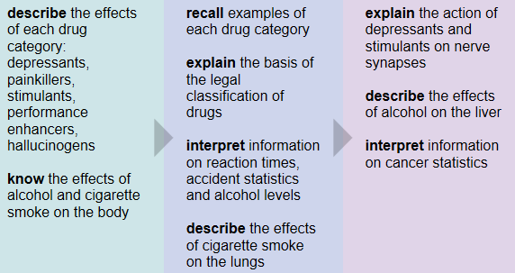
Key Information
Drugs are chemicals that can alter the way the body works. There are different types of drugs, and they have different effects on the body.

Tobacco and alcohol are legal recreational drugs which have potentially serious effects on the body. Illegal drugs are classified on a scale from Class A - the most dangerous - to Class C - the least dangerous.
Revision Ideas
- Make a key words definition table for the different types of drugs and their effects
- Write a problem page column on the effects of drinking and smoking on the body.

QWC Question (6 marks)
When answering a QWC question remember the following points: Use correct science vocabulary, organise ideas, avoid using “it”, and write in full sentences. You also need to try and keep you answer relevant to the question. A good way to do all this is to write out important key vocabulary and then use them to structure your answer. Underlining them will help you keep track and highlight to the examiner your good use of key terms,
Question – This question is about the effects of smoking on the body.
In 2007 smoking was banned in all work and public places. Describe the main chemicals in cigarettes, and explain how they can lead to poor health and even death. (6marks)
Important words list
Carbon Monoxide
Nicotine
Tar
Particulates
Heart Disease
Emphysema
Bronchitis
Cancer
Smokers Cough
Lungs
B1f: Staying in Balance
Grade E Grade C Grade A
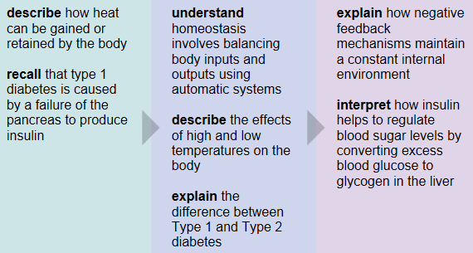
Key Information
Conditions in the body are controlled to provide a constant internal environment. This is called homeostasis. The conditions that must be controlled include body temperature, water content, carbon dioxide level and blood sugar level.

Hormones are chemicals secreted by glands. They travel through the bloodstream and affect target organs.
Revision Ideas
- Draw a cartoon strip showing how a person’s body would react to being too cold or too hot.
- Make a revision card on diabetes and insulin.

QWC Question (6 marks)
When answering a QWC question remember the following points: Use correct science vocabulary, organise ideas, avoid using “it”, and write in full sentences. You also need to try and keep you answer relevant to the question. A good way to do all this is to write out important key vocabulary and then use them to structure your answer. Underlining them will help you keep track and highlight to the examiner your good use of key terms,
Question – This question is about your body responding to change.
It is important to keep the body at 37’c. Describe how the body responds to high and low temperatures and explain what would happen if the body gets too hot or cold (6marks)
Important words list
Sweating
Increase blood flow
Heat stroke
Dehydration
Shivering
Respiration
Hypothermia
Exercising
Less blood flow near surface
B1g: Controlling Plant Growth
Grade E Grade C Grade A
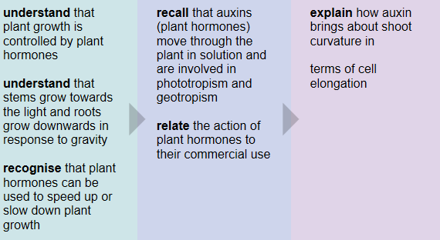
Key Information
A 'tropism' is a growth in response to a stimulus. Plants grow towards sources of water and light, which they need to survive and grow.

Auxin is a plant hormone produced in the stem tips and roots, which controls the direction of growth. Plant hormones are used in weed-killers, rooting powder and to control fruit ripening.

Revision Ideas
- Design an experiment to look at the effect of light on cress seeds.
- Write a (6 Mark) revision question on using plant hormones and write a mark scheme.
QWC Question (6 marks)
When answering a QWC question remember the following points: Use correct science vocabulary, organise ideas, avoid using “it”, and write in full sentences. You also need to try and keep you answer relevant to the question. A good way to do all this is to write out important key vocabulary and then use them to structure your answer. Underlining them will help you keep track and highlight to the examiner your good use of key terms,
Question – This question is plant hormones.
A plant is sensitive. It responses to different stimuli. Describe how a plants roots and shoots respond to light and gravity. (6marks)
Important words list
Positive
Negative
Phototropism
Geotropism
Gravity
Light
Roots
Shoots
Auxin
B1h: Variation and Inheritance
Grade E Grade C Grade A
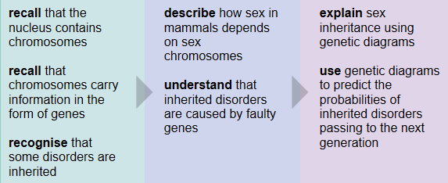
Key Information
Some characteristics of a living thing are caused by the environment, some by inherited factors, while others are caused by a combination of environment and inherited factors.

Male mammals carry XY sex chromosomes - female mammals carry XX sex chromosomes. Inherited disorders are caused by faulty genes on these chromosomes.

Different versions of a gene are called alleles, and these alleles can be dominant or recessive. Genetic diagrams can show the possible outcomes of a particular cross.

Revision Ideas
- Make a card sort for inherited and environmental characteristics
- Draw a diagram showing how genetic variation comes about showing a monohybrid cross
QWC Question (6 marks)
When answering a QWC question remember the following points: Use correct science vocabulary, organise ideas, avoid using “it”, and write in full sentences. You also need to try and keep you answer relevant to the question. A good way to do all this is to write out important key vocabulary and then use them to structure your answer. Underlining them will help you keep track and highlight to the examiner your good use of key terms,
Question – This question is variation
All the students in Harrison’s class are unique. Describe the difference between inherited and characteristics and those influenced by the environment and explain what causes variation (6marks)
Important words list
Gametes
Fertilisation
Mutations
Inherited
Environmental
Chromosomes
Genes
Variation

