**B2 Module Summary**

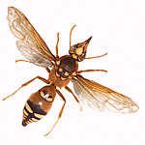

**Classifying Arthropods**

Insects – 6 legs e.g. beetle  
Arachnids – 8 legs e.g. spider  
Crustaceans – at least 10 legs e.g. crab  
Myriapods – lots of legs e.g. millipede

**Classifying Organisms**

Using KPCOFGS system. Some animals have characteristics of more than one group, so it is better to look at their DNA.

**Species Definition**

A group of similar organisms that can interbreed to produce fertile offspring.

**Hybrids**

These are the offspring of 2 different species. E.g. A lion and a tiger = a liger. Hybrids are infertile (proving that their parents were from different species).

**5 Kingdoms – Groups of organisms based on characteristics**

Animals (split into Vertebrates and Invertebrates)

Plants

Fungi

Protoctista

Bacteria

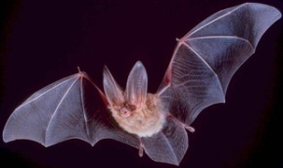

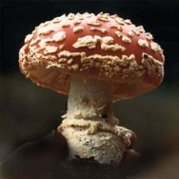

**Pyramids of numbers** show the numbers of organisms at each stage of a food chain

**Pyramids of biomass** show the mass of living material at each stage of a food web or chain

**Nitrogen is recycled in nature**:

• plants take in nitrates from the soil to make protein for growth;

• feeding passes nitrogen along a food chain or web;

• nitrogen compounds in dead plants and

animals are broken down by decomposers

into nitrates and returned to the soil.

• soil bacteria and fungi, acting as decomposers, convert proteins and urea into ammonia;

• the conversion of this ammonia to nitrates by nitrifying bacteria;

• the conversion of nitrates to nitrogen gas by denitrifying bacteria;

• the fixing of nitrogen gas by nitrogen-fixing bacteria living in root nodules or the soil or by the action of lightning.

**Carbon is recycled in nature:**

• plants remove CO2 from the air by photosynthesis;

• feeding passes carbon along a food chain or web;

• plants and animals release CO2 into the air, as a product of respiration;

• soil bacteria and fungi, acting as

decomposers, release CO2 into the air by respiration;

• burning of fossil fuels (combustion) releases CO2

Carbon is recycled in the sea:

• marine organism make shells made of

carbonates;

• shells become limestone;

• carbon returns to air as carbon dioxide

during volcanic eruption or weathering.

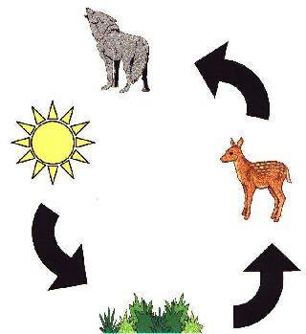

**Animals compete for** shelter, food, water and mates

**Plants compete for** light, water, minerals and space

An ecological niche is the role of the organism in the ecosystem.

Predator-Prey

The numbers of prey affect the numbers of predators and vice versa. If prey numbers decrease, predators will decrease. If prey increase, predators will increase. Too many predators lower the numbers of prey. This pattern is called **cyclic fluctuation**.

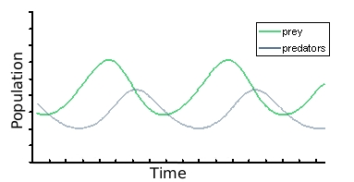

Parasites

These live on a host and take nutrients. They cause harm to the host. E.g. a tapeworm in a human

Cleaner Species

One species helps to clean another species by eating its parasites. E.g. sharksucker fish and sharks.

Mutualism

Species help each other and become dependent on each other. E.g. nitrogen-fixing bacteria living in root nodules of legume plants.

**Surface Area to Volume Ratio (H)**Ratio = SA/Vol

Organisms that have a large SA compared to their Volume may lose more heat and water. Cacti have a large volume and reduced SA, so lose less water.

Camel Adaptations

* Store fat in their hump to stop them being too hot and also for food supplies
* Bushy eyelashes to stop sand
* Large feet to spread out their weight

Polar Bear Adaptations

* Thick fur, white for camouflage
* A layer of blubber
* Small ears
* Large feet to spread out weight

Cacti Adaptations

* Very long roots to reach water
* Store water in stem
* Thick waxy cuticle to cut water loss
* Stem photosynthesises
* Leaves are spines to reduce surface area, to reduce water loss

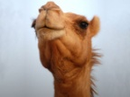

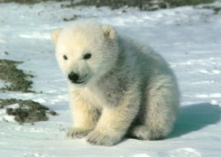

**Lamarck’s Theory of Evolution (H)**Has since been proved to be incorrect. Lamarck though that animals developed characteristics based on their needs. It was acquired over their lifetime.

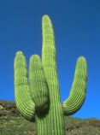

Human Population Growth

* Exponential growth (growing at an ever-increasing rate)
* More people use more resources and cause **global warming**, **ozone depletion** and **acid rain** (from sulphur dioxide released when fossil fuels burn)
* Carbon footprint (H): the total greenhouse gas given off by a person or organisation

Darwin’s Theory of Natural Selection

* There is variation
* Best adapted organisms will survive better and will pass on their genes to their offspring
* Eventually the adaptation becomes widespread over generations

Examples of Natural Selection

* Peppered Moth (light and dark forms)
* Rats resistant to rat poison (warfarin)
* Bacteria resistant to antibiotics e.g. MRSA

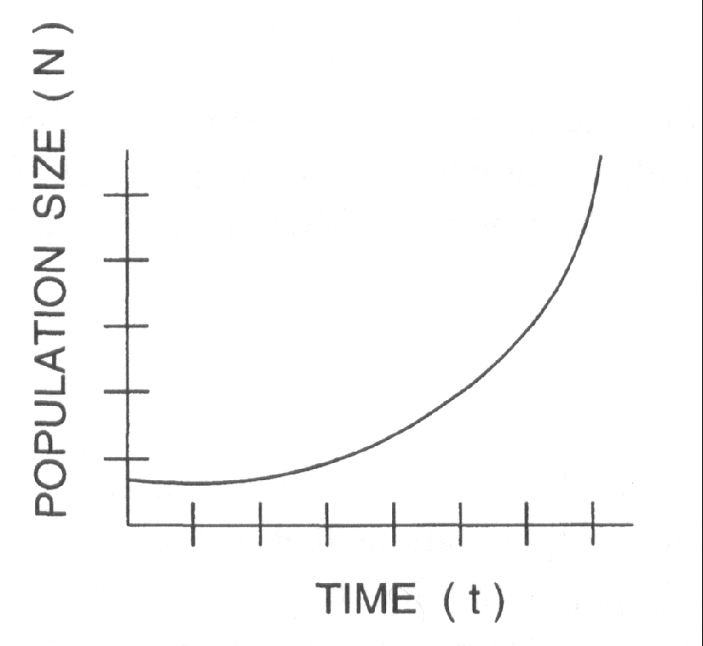

Endangered Species

Species are endangered when there are very few of them left in the world. When they completely die out they are **extinct**.

Animals can become extinct due to climate change or humans polluting the environment and destroying habitats. Organisations try to save animals from extinction by conserving habitats and setting up breeding programmes.

The Giant Panda

Why save it? It will protect the habitat which may have plants used in medicines. The panda brings in tourism and money

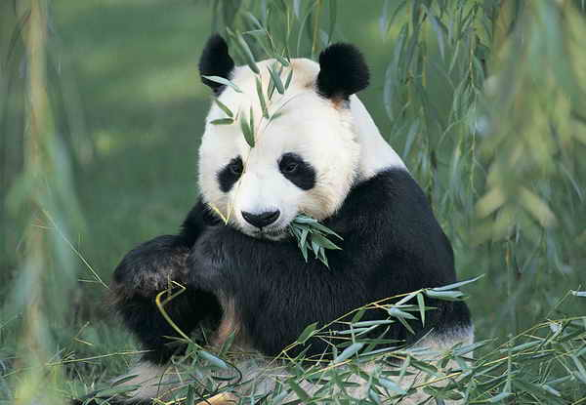

Indicator Species

* Presence or absence of indicator species helps to estimate pollution levels.
* The stonefly larva can only live in clean water
* Bloodworms live in polluted water
* Lichen grows on trees in clean areas, but is killed by sulphur dioxide

Whaling

For Whaling

* Parts used for oil, tennis rackets, perfumes, piano keys, cosmetics
* Tradition
* Scientific research

Against Whaling

* It’s cruel
* Brings in tourism from whale watching

**Fishing Quotas** could be brought in – limit the number of fish/whales that can be caught to help to sustain the populations in the sea.