Explain why it is dangerous to move a person with a suspected fracture  - Might cause further damage e.g. to nerves | Explain how cartilage turns into bone  - Ossification  - Add calcium and phosphorus
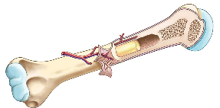Describe the structure of the long bone  - Head with cartilage  - Shaft with bone marrow | Describe how the arm bends and straightens  - 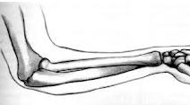Bend: bicep contracts, tricep relaxes (antagonistic)  - Straighten: bicep relaxes, tricep contracts
Explain advantages of an internal skeleton  - Flexible  - Attach Muscles  - Growth with the body  - Framework | 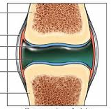Describe the structure of a synovial joint, explain the function of each part  - Synovial membrane (holds in fluid), Synovial fluid (lubricates joint), Ligament (attaches bones together), Cartilage (cushions)
Describe range of movement in joints  - Ball and socket (360 degrees)  - Hinge (lever movement) | Elderly people are more prone to fractures  - Osteoporosis (soft bones)

Define a single circulatory system  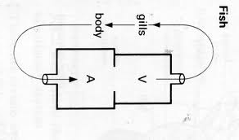Blood does one circuit through heart, only 2 chambers | Define a double circulatory system  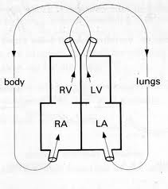  Blood goes through heart twice in one circuit, heart has 4 chambers
Describe the contribution of Galen  - Heart has chambers  - Heart sucked in blood | Describe the contribution of Harvey  - Valves in veins  - Capillaries
Explain the advantages of double circulatory system  - Blood can be pumped at higher pressure | Describe the function of an artificial pacemaker  - Control heart beat
Explain sequence of contraction and valves in the heart  - 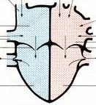Atria contract, AV valves open, Ventricles contract, AV valves close and semi lunar valves open | Describe how the pacemaker coordinates heart muscle contraction  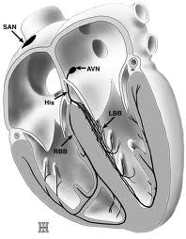  - Impulse from SAN causes atria to contract, stimulates AVN, impulse from AVN causes ventricles to contract

Explain the consequence of a hole in the heart  - Blood moves directly between sides of the heart  - Less oxygen in the blood  - Fixed by surgery | Explain the consequences of a damaged or weak heart valve  - Less effective blood circulation  - Fixed by artificial valves
Understand why all unborn babies have a hole in the heart  - Don’t need a double circulatory system in the womb as they get oxygen from the mum | Explain advantages and disadvantages of an artificial pacemaker over a heart transplant  - No risk of reject or need to take immune-suppressants  - Body might react with material
Explain the consequences of a blocked coronary artery  - Reduces blood flow to the heart  - Treated by bypass surgery | Describe the processes of  - blood donation: Blood taken by needle in vein  - blood transfusion: Blood given through IV
Describe the processes of blood clotting  - Platelets meets damaged blood vessels, series of chemical reactions, fibrin forms a mesh of fibres | Define agglutination  - Blood clumping caused by unsuccessful blood donations
Complete the table
Blood Type | Antigens | Antibodies
A | A | B
B | B | A
AB | A & B | None
O | None | A & B

Explain how fish gills work  - Forcing water across filaments | Explain how permeable skin of amphibians work  - Gas exchange by diffusion through the skin
Explain adaptations of gas exchange surfaces (alveoli)  - Permeable, moist, large surface area, good blood supply, thin lining | Describe how the respiratory system protects itself against disease  - Mucus and ciliated cells
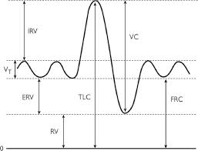  Define tidal air  - Amount taken in and out of the lungs in a normal breath | Define vital capacity air  - Total amount of air you can breathe out of your lungs
Define residual air  - Amount of air left in the lungs when you fully breathe out | Describe asbestosis and state cause  - Industrial cause  - Inflammation and scarring limits gas exchange
Describe cystic fibrosis and state cause  - Genetic cause  - Too much mucus in the bronchioles | Describe lung cancer and state cause  - Lifestyle cause  - Cells grow rapidly, reducing surface area
Describe symptoms and treatment of asthma
- Treatment: Inhaler
- Symptoms: Lining becomes inflamed, fluid builds up in airways, muscles contract, constricting the airways

Explain the importance of physical digestion  - So food pass more easily through  - Provides a larger surface area | Explain where bile is made and how it improves fat digestion  - Made in the gall bladder  - Increases the surface area of fats
Explain why stomach pH is acidic where as mouth and small intestine is alkaline  - Optimum for enzymes  - Stomach acid kills bacteria | Describe the breakdown of starch as a two step process  - Amylase: Starch Maltose  - Maltase: Maltose Glucose
Enzymes: complete the table
Enzyme | Substrate | Product
Carbohydrase/ Amylase | Sugars/Starch | Glucose
Protease | Proteins | Amino acids
Lipase | Fats | Fatty acids and glycerol

Explain why large molecules are broken down to small molecules in digestion  - To be absorbed in the blood stream | 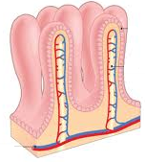Explain how the small intestine is adapted to efficient absorption of food  - Villi to increase surface area  - Good blood supply  - Permeable  - Thin lining

Explain the importance of maintaining constant water concentration in blood plasma  - So doesn’t affect water concentration in cells | 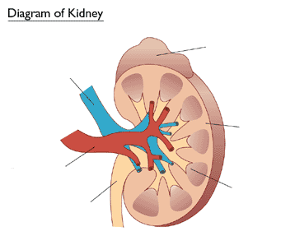  - Cortex  - Medulla  - Renal Pelvis  - Ureter  - Renal Artery  - Renal Vein
Explain how the function of the kidney tubule forms urine  - Glomerulus & capsule  - Filter blood  - Selective reabsorption  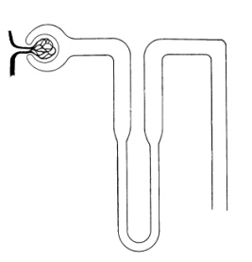  - Loop controls water and salt levels | Explain the principle of a dialysis machine  - Dialysis removes waste by diffusion  - Dialysis fluid has the same concentrations of sodium and glucose as the blood so these aren’t removed
Explain factors that affect urine concentration
- Water intake, heat, exercise
State where urea is made  - Liver | State what urea is made from  - Excess amino acids
Explain how concentration of urine is controlled by Anti-diuretic hormone (ADH)  - Increases the permeability of kidney tubules so more water is reabsorbed into the blood  - Controlled by negative feedback | Explain how the body responds to increased concentration levels of carbon dioxide  - Detected by the brain, increases breathing  Explain why high levels of carbon dioxide is toxic  - Makes blood acidic

Describe the role of oestrogen  - Thickens lining of the uterus | Describe the role of progesterone  - Maintains lining of the uterus
Describe the role of FSH  - Stimulates development of the egg | Describe the role of LH  - Causes ovulation (egg release)
Negative feedback controls the menstrual cycle  - Progesterone inhibits FSH | Explain how the contraceptive pill works  - Progesterone to stop eggs from developing
Describe artificial insemination to treat infertility  - Sperm placed in woman’s uterus | Describe use of FSH to treat infertility
Describe in vitro fertilisation (IVF) to treat infertility  - Fertilisation outside of the body | Describe egg donation to treat infertility  - Uses donors eggs for IVF
Describe surrogacy to treat infertility  - Use another woman’s uterus | Describe ovary transplants to treat infertility  - Ovary from another woman transplanted
Describe how foetal development can be checked, test for Down’s Syndrome
- Amniocentesis (look at sample of amniotic fluid) & Chromosomal Analysis (look at sample of placenta)
- Risk of miscarriage

Explain causes of extremes in heights  - Genes  - Hormones | State where human growth hormone is made and where is effects  - Pituitary Gland, effects the long bones
Describe how baby’s growth is monitored and why  - Check developing correctly  - Measure length, mass and head size | Explain causes of increased life expectancy in modern times  - Less industrial disease, healthier diet, modern treatments, better housing
State 3 problems in the supply of donor organs  - Shortage of donors  - Tissue match  - Size and age | State 4 problems of using mechanical replacements of organs  - Size  - Power supply  - Materials used  - Body reactions
Describe the 2 problems with transplants  - Rejection  - Immuno-suppressive drug treatment | Explain why donors can be living  - You only need one kidney  - Part of the liver can be taken
Describe the advantages of a register of donors  - People can volunteer to donate their organs | Describe the disadvantages of a register of donors  - Are people too lazy to sign up?

