Explain advantages of an internal skeleton | Explain how cartilage turns into bone
Describe the structure of the long bone | Describe how the arm bends and straightens
Explain why it is dangerous to move a person with a suspected fracture | Describe the structure of a synovial joint, explain the function of each part
Describe range of movement in joints | Explain why elderly people are more prone to fractures

Define a single circulatory system | Define a double circulatory system  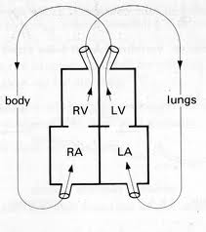
Describe the contribution of Galen | Describe the contribution of Harvey
Explain the advantages of double circulatory system over a single circulatory system | Describe the function of an artificial pacemaker
Explain sequence of contraction and valves in the heart | Describe how the pacemaker coordinates heart muscle contraction#  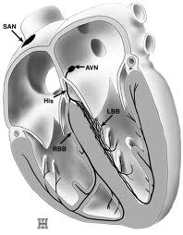

Explain the consequence of a hole in the heart | Explain the consequences of a damaged or weak heart valve
Understand why all unborn babies have a hole in the heart | Explain advantages and disadvantages of an artificial pacemaker over a heart transplant  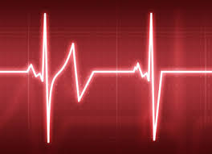
Explain the consequences of a blocked coronary artery | Describe the processes of  - blood donation  - blood transfusion
Describe the processes of blood clotting | Define agglutination
Complete the table
Blood Type | Antigens | Antibodies
A

B

AB

O

Explain how fish gills work | Explain how permeable skin of amphibians work
Explain adaptations of gas exchange surfaces (alveoli) | Describe how the respiratory system protects itself against disease
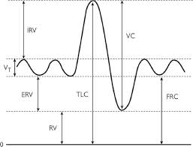  Define tidal air | Define vital capacity air
Define residual air | Describe asbestosis and state cause
Describe cystic fibrosis and state cause | Describe lung cancer and state cause
Describe symptoms and treatment of asthma

Explain the importance of physical digestion | Explain where bile is made and how it improves fat digestion
Explain why stomach pH is acidic where as mouth and small intestine is alkaline | Describe the breakdown of starch as a two step process
Enzymes: complete the table
Enzyme | Substrate | Product
Carbohydrase/ Amylase

Protease

Lipase

Explain why large molecules are broken down to small molecules in digestion | Explain how the small intestine is adapted to efficient absorption of food

Explain the importance of maintaining constant water concentration in blood plasma | 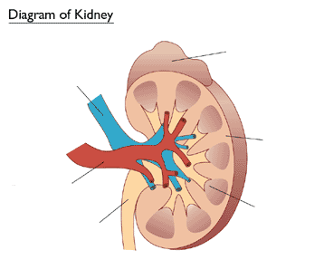
Explain how the function of the kidney tubule forms urine  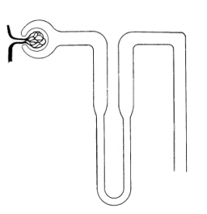 | Explain the principle of a dialysis machine
State where urea is made | State what urea is made from
Explain how concentration of urine is controlled by Anti-diuretic hormone (ADH) | Explain factors that affect urine concentration
Explain how the body responds to increased concentration levels of carbon dioxide

Explain why high levels of carbon dioxide is toxic

Describe the role of oestrogen | Describe the role of progesterone
Describe the role of FSH | Describe the role of LH
Explain how negative feedback controls the menstrual cycle | Explain how the contraceptive pill works
Describe artificial insemination to treat infertility | Describe use of FSH to treat infertility
Describe in vitro fertilisation (IVF) to treat infertility | Describe egg donation to treat infertility
Describe surrogacy to treat infertility | Describe ovary transplants to treat infertility
Describe how foetal development can be checked

Explain causes of extremes in heights | State where human growth hormone is made and where is effects
Describe how baby’s growth is monitored and why | Explain causes of increased life expectancy in modern times
State 3 problems in the supply of donor organs | State 4 problems of using mechanical replacements of organs
Describe the 2 problems with transplants | Explain why donors can be living
Describe the advantages of a register of donors | Describe the disadvantages of a register of donors

