1. Kathy grows her own tomato plants.
(a) The soil Kathy uses does not have enough nitrate.
Some of her plants show signs of nitrate deficiency.
Describe two signs of nitrate deficiency the plants would show.
1 .....................................................................................................................
2 .....................................................................................................................
[2]

(b) Kathy decides to use fertiliser on her soil.
Look at the picture of the bag of fertiliser.
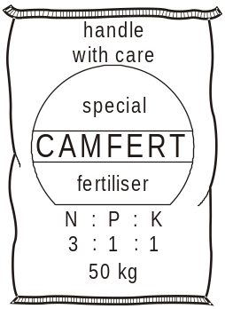

(i) The plants grown by Kathy use the nitrates.
What do the plants make using the nitrates?
...............................................................................................................
[1]

(ii) The fertiliser also contains magnesium.
What do plants use the magnesium for?
...............................................................................................................
[1]

(c) Kathy has grown too many tomatoes to eat all at once.
She decides to turn them into tomato chutney by cooking them with vinegar.
Vinegar helps to preserve the tomatoes.
Explain how.
........................................................................................................................
........................................................................................................................
[2]

(d) Kathy’s friend John also grows tomatoes.
However, John does not use any soil.
The diagram shows John’s plants.
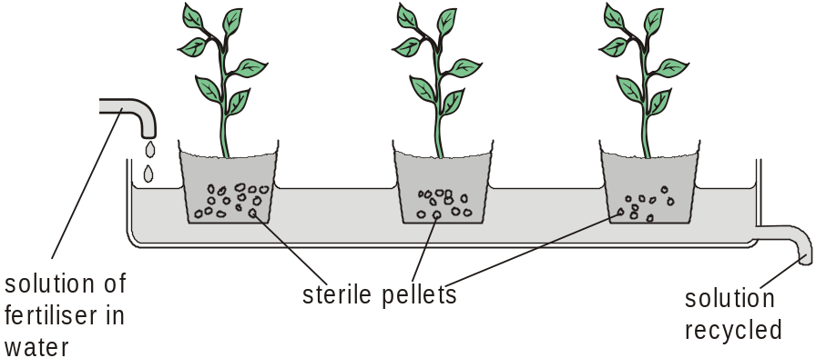

(i) Write down the name given to the method John uses.
...............................................................................................................
[1]
(ii) Write down one advantage and one disadvantage of this method compared to growing plants in soil.
advantage .............................................................................................
...............................................................................................................
disadvantage ........................................................................................
...............................................................................................................
[2]
[Total 9 marks]

2. Look at the diagram. It shows a food chain.
40 lettuces 100 caterpillars 10 blue tits
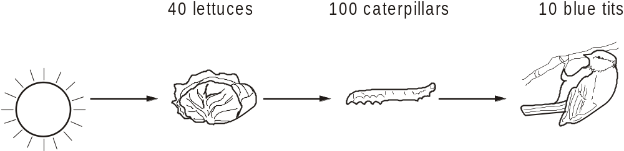

(a) (i) Finish the pyramid of numbers to include the caterpillars and blue tits.
Make sure the bars are drawn to scale.

[1]

(ii) A pyramid of biomass for this food chain would be a different shape.
Describe how the shape would be different.
You may use a diagram to help you answer.
...............................................................................................................
...............................................................................................................
[1]

(b) Energy is ‘lost’ from each stage of the food chain.
Write down one way in which energy is lost.
........................................................................................................................
[1]

(c) When blue tits die, nitrogen in their bodies can be used by plants.
This is part of the nitrogen cycle.
The table contains some bacteria found in the nitrogen cycle.
Describe the role of each bacterium next to the name.
bacteria | role in nitrogen cycle
denitrifying bacteria
nitrifying bacteria
nitrogen-fixing bacteria
[3]
[Total 6 marks]

3. The diagram shows part of the nitrogen cycle.
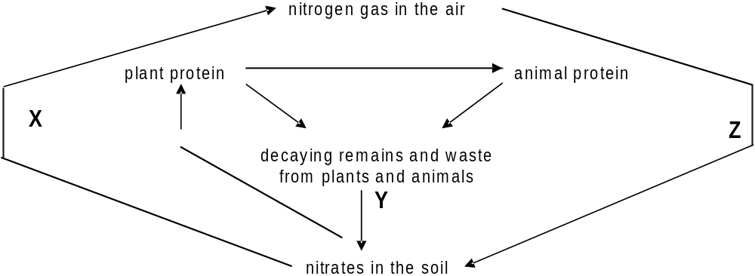

(a) What types of microbes cause the changes shown by arrows X, Y and Z?
X ....................................................................................................................
Y ....................................................................................................................
Z ....................................................................................................................
[3]

(b) In tropical rainforests, there is a lot of decaying plant and animal material.
However, the amount of nitrate in the soil is low.
Suggest why the amount of nitrate in the soil is low.
........................................................................................................................
........................................................................................................................
[1]
[Total 4 marks]

4. Woolly mammoths were a type of prehistoric elephant.
They used to live in very cold parts of the world.
They became extinct about 10,000 years ago.
The dead bodies of some mammoths have been found preserved in frozen ground.
Some of the mammoths have been taken out of the frozen ground.
The bodies then started to decay.
Explain why they started to decay.
.................................................................................................................................
.................................................................................................................................
.................................................................................................................................
.................................................................................................................................
[Total 3 marks]

5. The diagram shows a cross section through a plant stem.
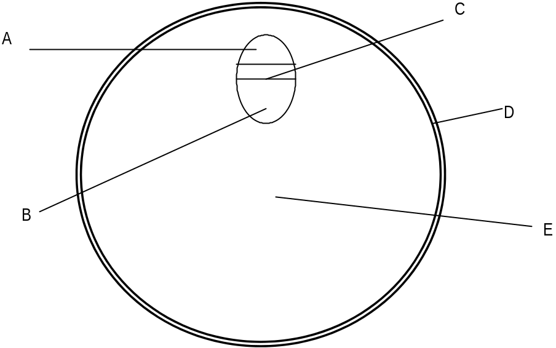

(a) (i) Which label letter shows the xylem?
Choose from A, B, C, D, or E. ……………………………….
[1]

(ii) Which label letter shows the phloem?
Choose from A, B, C, D, or E. ……………………………….
[1]

(b) Water carries dissolved minerals up to the leaves through the xylem.
The table shows how plants use some of these minerals.
Complete the table. One example is done for you.
mineral | one substance made using the mineral | use of the substance in the plant
phosphate | DNA | It stores genetic information
magnesium
nitrate
[4]

(c) Water travels through the plant by a process called transpiration.
(i) Give two more uses of water in a plant.
Water carries dissolved materials up to the leaves.
1 ............................................................................................................
2 ............................................................................................................
[2]

(ii) Describe how a plant loses water from its leaves.
...............................................................................................................
...............................................................................................................
...............................................................................................................
...............................................................................................................
[2]

(d) Rob noticed that his tomato plants wilted on a hot and windy day.
His friend said this was due to transpiration.
Explain why transpiration rate is increased on hot and windy days.
........................................................................................................................
........................................................................................................................
........................................................................................................................
[3]
[Total 13 marks]

6. Kate is investigating water loss in plants.
She sets up three flasks, A, B and C.
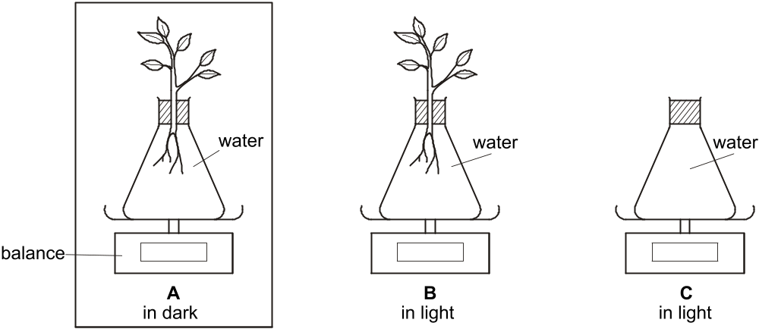

The plants in A and B are identical.
All three flasks are left in the same room, at the same temperature, for 24 hours.
A is kept in a cupboard in the dark.
B and C are below a light.
Look at Kate’s results.
 | mass at start in g | mass after 24 hours in g
A | 810 | 790
B | 810 | 740
C | 720 | 720

(a) Explain the difference between the results for A and B.
........................................................................................................................
........................................................................................................................
........................................................................................................................
[2]

(b) Why did Kate set up flask C?
........................................................................................................................
........................................................................................................................
[1]

(c) Kate repeats the experiment, but in a warmer room.
Here are her results.
 | mass at start in g | mass after 24 hours in g
A | 810 | 770
B | 810 | 720
C | 720 | 720
Explain the difference between these results and her first set of results.
........................................................................................................................
........................................................................................................................
[1]

(d) The diagram shows a cell from one of the plants.
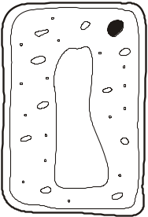
After the experiment, the plants are left until there is no water in the flasks.
The diagram below shows the same cell when there is no water left in the flasks.
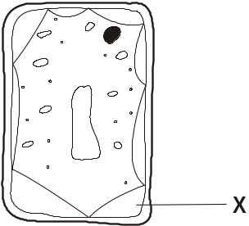

(i) What word describes the cell now?
...............................................................................................................
[1]

(ii) What is in the area marked X?
...............................................................................................................
[1]
[Total 6 marks]

7. Look at the diagram.
It shows the cellular structure of a leaf.
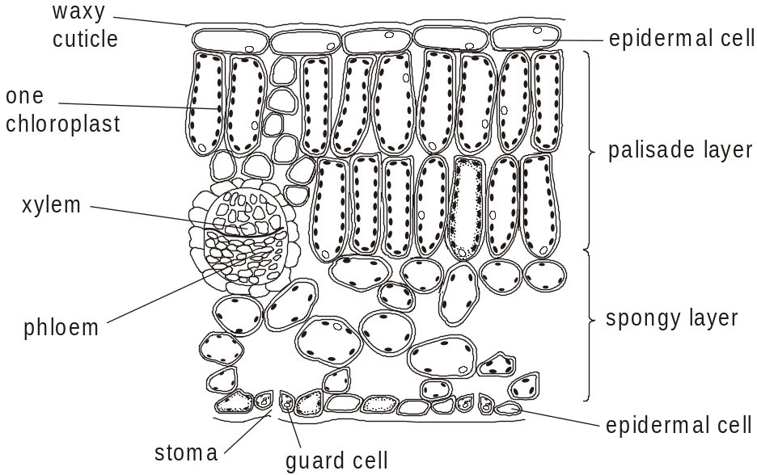

(a) (i) Describe the job of xylem.
...............................................................................................................
...............................................................................................................
[1]

(ii) Describe the structure of xylem.
...............................................................................................................
...............................................................................................................
[1]

(b) The leaf is adapted for efficient photosynthesis.
(i) Photosynthesis needs efficient gas exchange.
Explain how the spongy layer is adapted for efficient gas exchange.
...............................................................................................................
...............................................................................................................
...............................................................................................................
[2]

(ii) Describe and explain one other way the leaf is adapted for photosynthesis.
...............................................................................................................
...............................................................................................................
[1]
[Total 5 marks]

8. Chris is a farmer.
He grows cabbages in one of his fields.
He uses pesticides to kill the caterpillars that eat his cabbages.
(a) (i) Chris’s neighbour, Matt, tells Chris he should not use pesticides.
Suggest the reasons why he should not use pesticides.
...............................................................................................................
...............................................................................................................
...............................................................................................................
[2]

(ii) Chris tries another way to kill the caterpillars.
He puts up nesting boxes for birds.
He hopes the birds will eat the caterpillars.
Suggest why this might not work.
...............................................................................................................
...............................................................................................................
[1]

(b) (i) Chris notices that his cabbages have yellow leaves.
He adds fertiliser containing magnesium.
After a few weeks he notices that his cabbages grow green leaves.
Explain why.
...............................................................................................................
[1]

(ii) Cabbages grow faster with green leaves than yellow leaves.
Explain why.
...............................................................................................................
[1]
[Total 5 marks]

9. The diagram shows the inside of a leaf.
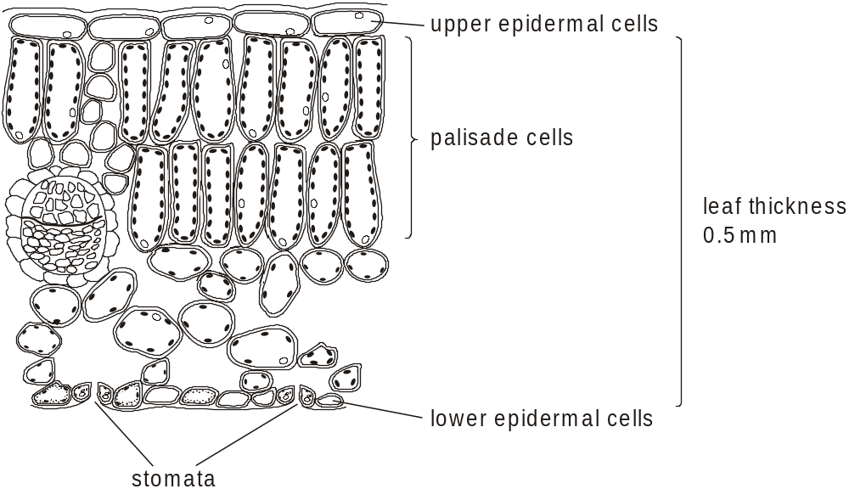

(a) Leaves contain veins.
Describe one job of the veins.
........................................................................................................................
[1]

(b) Upper epidermal cells are adapted so that leaves can photosynthesise efficiently.
Describe one way the cells are adapted for this.
........................................................................................................................
........................................................................................................................
[1]

(c) Carbon dioxide diffuses from the stomata to the palisade cells.
Leaves are adapted for efficient diffusion of carbon dioxide between the stomata and palisade cells.
Describe one way that leaves are adapted for this.
........................................................................................................................
........................................................................................................................
[1]

(d) The diagram shows a palisade cell.
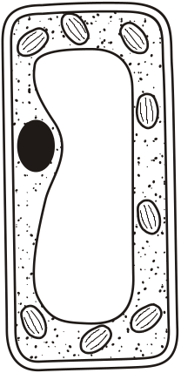
If a plant wilts, the cells may become plasmolysed.

Finish the diagram below to show what the cell would look like if it were plasmolysed.
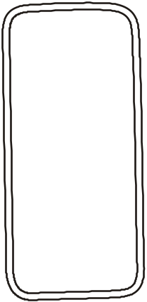
[1]

(e) Animal cells never become plasmolysed.
Explain why.
........................................................................................................................
[1]
[Total 5 marks]

10. When Eileen cuts her grass, she puts the cuttings in a heap at the end of her garden.
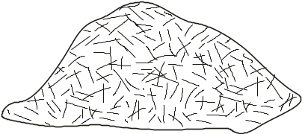
The grass cuttings decay to form compost.
Eileen adds the compost to the soil in her garden.

(a) Decay is caused by decomposers.
The decomposers release carbon dioxide. This is part of the carbon cycle.
Put  around two processes that release carbon dioxide.
combustion
diffusion
photosynthesis
respiration
translocation
transpiration
[2]

(b) Decomposers are also examples of saprophytes.
What does saprophyte mean?
........................................................................................................................
[1]

(c) The grass grows and decays.
This is part of the nitrogen cycle.
Look at the list.
Put a  around the one that releases nitrogen gas.
denitrifying bacteria
lightning
nitrifying bacteria
nitrogen-fixing bacteria
respiration
[1]

(d) Grass needs nitrogen compounds to grow.
Explain why.
........................................................................................................................
[1]
[Total 5 marks]

11. Matt has a compost heap in his garden.
He fills it with dead leaves and grass cuttings which decay to form compost.
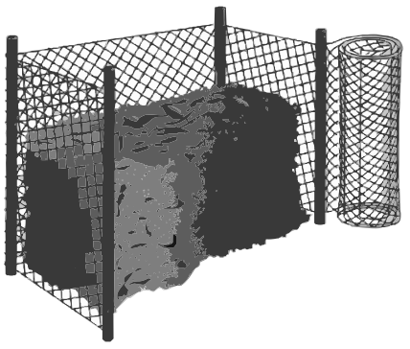

(a) (i) Matt adds earthworms to the compost to increase the rate of decay.
Explain why adding earthworms increases the rate of decay.
...............................................................................................................
...............................................................................................................
...............................................................................................................
[2]

(ii) What word describes earthworms?
Put a 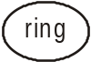 around the correct answer.
decomposers detritivores producers saprophytes
[1]

(b) Matt uses his compost to fertilise the soil in his garden.
The compost continues to break down as part of the nitrogen cycle.
Look at the diagram of part of the nitrogen cycle.
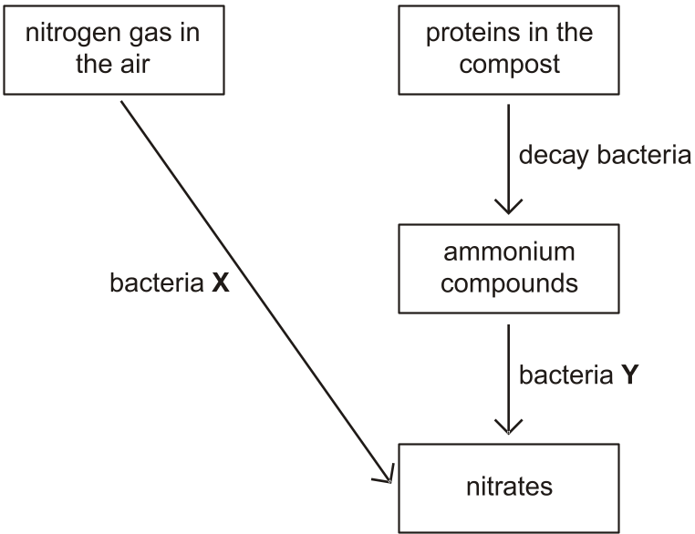

(i) What type of bacteria are bacteria X?
...............................................................................................................
[1]

(ii) What type of bacteria are bacteria Y?
...............................................................................................................
[1]
[Total 5 marks]

12. Look at the food chain found in Africa.
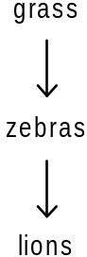
The diagrams below show how a zebra and a lion transfer energy.
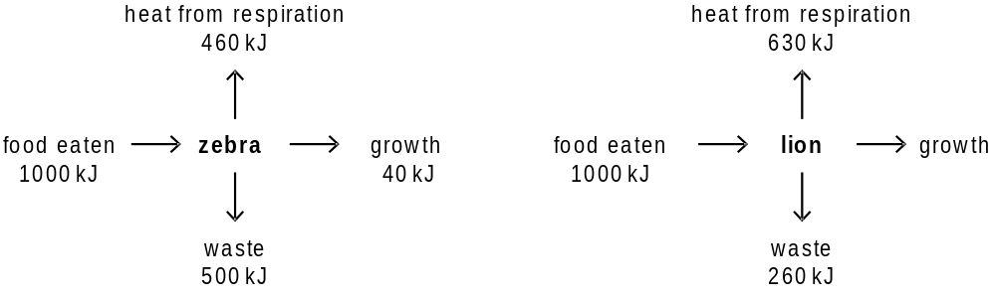

(a) (i) For every 1000 kJ of food energy, how much energy does the lion use for growth?
........................................................... kJ
[1]

(ii) For every 1000 kJ of food energy, the amounts of energy that a lion cub transfers as heat, growth and waste are different from an adult lion.
Suggest one way that the amounts of energy a lion cub transfers would be different from an adult lion.
...............................................................................................................
Explain your answer. ............................................................................
...............................................................................................................
[1]

(b) The efficiency of energy transfer from food to growth in lions is 11%.
The efficiency of energy transfer from food to growth in zebras is less than this.
(i) Calculate the efficiency of energy transfer from food to growth in zebras.
Show your working.

......................................................... %
[2]

(ii) The efficiency of energy transfer from food to growth in zebras is less than in lions.
This is because they lose more energy in their waste.
Suggest why.
...............................................................................................................
...............................................................................................................
[1]
[Total 5 marks]

13. John is a farmer. He uses organic farming techniques.
(a) One organic farming technique that John uses is to grow mainly peas and beans which are nitrogen-fixing crops.
This means that he does not have to use artificial nitrate fertilisers.
Suggest one advantage and one disadvantage of growing nitrogen-fixing crops instead of using nitrate fertilisers.
advantage ......................................................................................................
........................................................................................................................
........................................................................................................................
disadvantage .................................................................................................
........................................................................................................................
........................................................................................................................
[2]

(b) John’s neighbour Ed uses intensive farming techniques.
What does intensive farming mean?
........................................................................................................................
........................................................................................................................
[1]

(c) Ed does use artificial nitrate fertilisers.
He puts the fertilisers on to his fields when his crops start to grow.
(i) Nitrates are needed for plant growth.
Explain why.
...............................................................................................................
[1]

(ii) Nitrates are taken in by plant roots using active transport.
What is active transport?
...............................................................................................................
...............................................................................................................
...............................................................................................................
[2]

(iii) Nitrates move through a plant in the xylem vessels.
The nitrates are absorbed and move through plants faster on warm days than on cold days.
Write down one reason why.
...............................................................................................................
...............................................................................................................
[1]
[Total 7 marks]

14. Kate is growing geraniums in her garden.
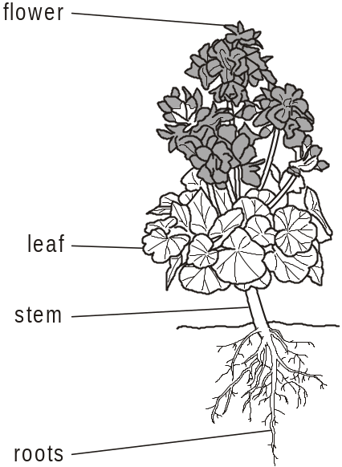

(a) Geranium leaves are adapted for efficient photosynthesis.
Describe two ways leaves are adapted for efficient photosynthesis.
1 .....................................................................................................................
........................................................................................................................
2 .....................................................................................................................
........................................................................................................................
[2]

(b) Plants lose water from their leaves. This is called transpiration.
Describe how transpiration happens.
........................................................................................................................
........................................................................................................................
........................................................................................................................
[2]

(c) Kate wants to put one of her geraniums in a pot.
She digs up one of them.
Unfortunately many of the roots break off.
She plants the geranium in a pot.
However, even though she waters it regularly, the geranium wilts (droops).
Look at the diagrams of different plant cells.
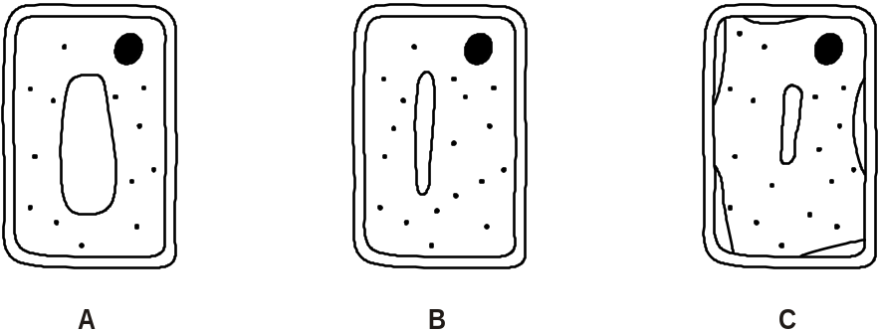

(i) Which cell is most likely to come from the leaves of the wilting geranium?
Choose from A, B or C.
.....................................................
[1]

(ii) What word describes cell A?
Put a around the best answer.
flaccid plasmolysed turgid
[1]
[Total 6 marks]

15. Chris grows tomato plants in a glass house.
He uses hydroponic farming techniques.
This means he does not grow his tomato plants in soil.
Instead he grows them with their roots in water.
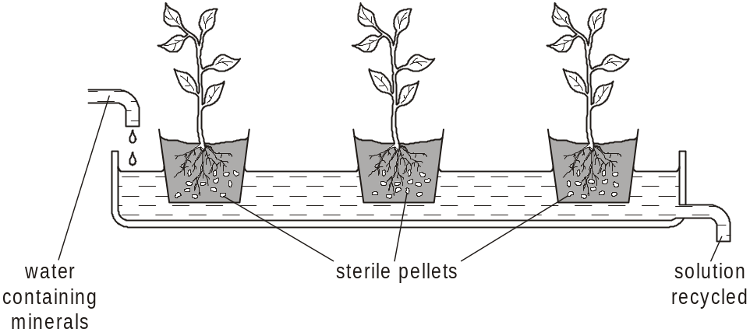
(a) (i) Chris adds different minerals to the water the tomato plants grow in.
If he does not do this, the plants will not be healthy and will not grow properly.
Draw a straight line to match each mineral deficiency with the example of poor growth caused by it.
Draw three lines only.
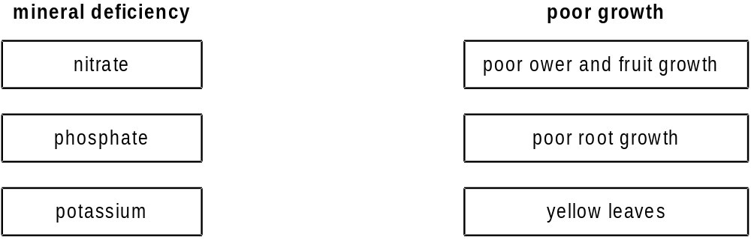
[2]
(ii) Minerals move through plants in vessels.
What is the name of the type of vessel that transports minerals?
...............................................................................................................
[1]
(b) Suggest one advantage of using hydroponic farming techniques compared to growing plants in soil.
................................................................................................................................................................................................................................................[1]
[Total 4 marks]

16. Look at the information about a farmland food chain.
 | number of individuals | mass of an individual in g | total biomass  in g
cabbages | 8 | 250 | ……………
caterpillars | 400 | 2 | 800
thrushes | 5 | 80 | 400
hawks | …………… | 200 | 200

(a) Complete the table.
[2]

(b) Use the data in the table to complete a pyramid of biomass.
• Use 1 cm square = 200 g.
• Label the pyramid.
The bar for cabbages has been done for you.
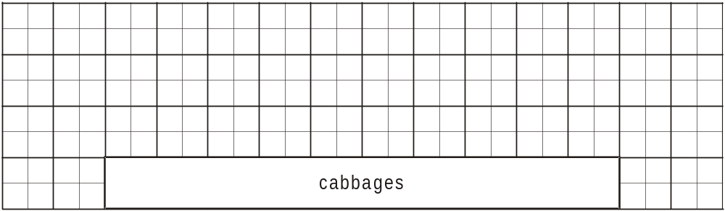
[2]
[Total 4 marks]

17. Bob has been cutting his grass.
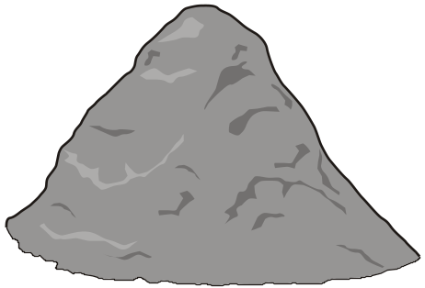

Bob puts his grass cuttings into a compost bin.
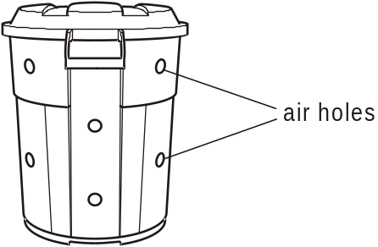

(a) Grass cuttings decay faster in the summer than in the winter.
Suggest why.
........................................................................................................................
[1]

(b) When grass cuttings decay, carbon dioxide is made.
What makes this carbon dioxide?
........................................................................................................................
[1]
(c) Bob adds some earthworms to his compost bin.
Suggest why.
........................................................................................................................
........................................................................................................................
........................................................................................................................
[2]
[Total 4 marks]

