Question: 5

(a) (i) A gene controlling coat colour in cats is sex linked. The two alleles of this gene are black and orange. When both are present the coat colour is called tortoiseshell.

Define the following terms:

gene............___________________________________________________________________________________________

allele................_____________________________________________________________________________________ [2]

(ii) Explain why there are no male tortoiseshell cats.

_____________________________________________________________________________________________________

_____________________________________________________________________________________________________

___________________________________________________________________________________________________[2]

Two pure breeding strains of snapdragon, a garden plant, were obtained. One strain had red flowers and the other had white flowers. The two strains were crossed yielding F1 plants all with pink flowers. The F1 were then interbred to produce F2 plants with the following colours:

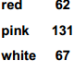
The following hypothesis was proposed:

Flower colour is controlled by a single gene with two codominant alleles.

(b) Complete the genetic diagram to explain this cross. Use the following symbols to represent the alleles:

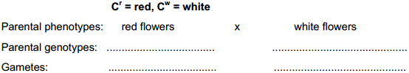

F1 genotypes: ..........

F1 phenotypes: ..........

Gametes: ..........

F2 genotypes: .............

F2 phenotypes: ............

Expected F2 phenotypic ratio:........... [6]

(c) A chi-squared test is carried out on the experimental data to determine whether the hypothesis is supported.

(i) Complete Table 1.1 by calculating the expected numbers.

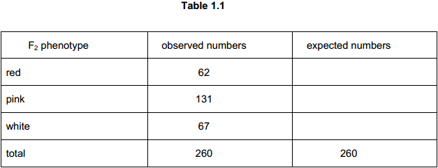
[3]

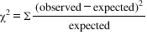The statistic is calculated in the following way:

(ii) Calculate the value of for the above data. Show your working.

value = ...........

[2]

(iii) The critical value of for this type of investigation with two degrees of freedom is 5.991.

Explain whether your answer to (b) (ii) supports the hypothesis.

__________________________________________________________________________________________________[1]

(d) Phenotype is influenced by genetic and environmental factors.

Describe one example of how the environment influences phenotype.

_____________________________________________________________________________________________________

_____________________________________________________________________________________________________

_____________________________________________________________________________________________________

___________________________________________________________________________________________________[2]

[Total: 18]

