Meselson and Stahl’s Evidence for Semi Conservative Replication of DNA
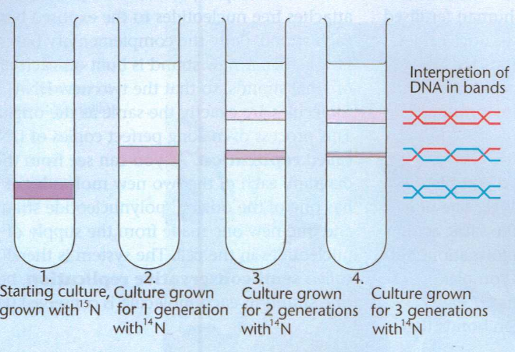

Meselson and Stahl’s Evidence for Semi Conservative Replication of DNA

