Organelle | Description | Function | Diagram
Nucleus | - The Largest organelle (10-20μm in diameter).  - Roughly spherical.  - It is double membrane bound | - Contains chromatin – mixture of DNA and associated proteins.  - It controls protein synthesis (makes mRNA)  - It will always divide before the cell itself divides | 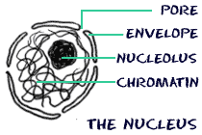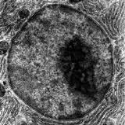
Nucleolus | - Area of dense chromatin within the nucleus  - It is a granular structure and is not membrane bound | - The nucleolus makes ribosomal RNA (rRNA) and assembles ribosomes | 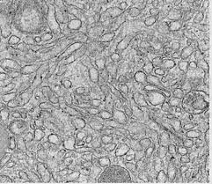
Rough Endoplasmic Reticulum | - Consists of flattened sacs called cisternae  - Continuous with the outer nuclear membrane.  - Studded with Ribosomes | - The ribosomes make protein which is then transported within the ER’s flattened sac-like sheets called cisternae.  - Some of the proteins are secreted by the cell, others are used within the cell. | 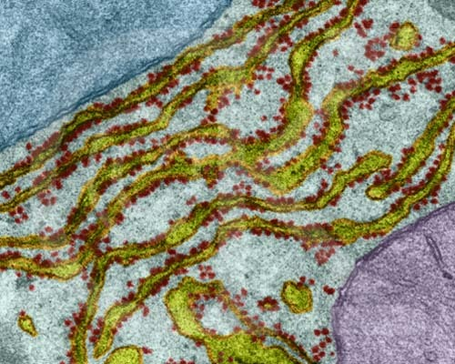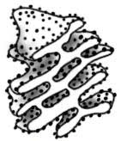
Smooth Endoplasmic Reticulum | - Consists of flattened sacs called cisternae  - Not studded with ribosomes | - Production of lipids | 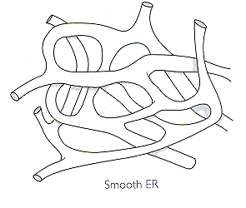
Golgi apparatus | - A stack of membrane bound flattened sacs. | - Receives proteins packaged in vesicles from the ER.  - Modifies proteins e.g. by the addition of sugars.  - Packages modified proteins into vesicles for transportation to the cell surface membrane and secretion out of the cell. | 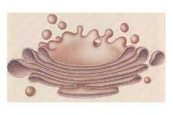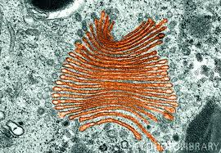
Ribosome | - Small organelle  - Not membrane bound  - Consists of two subunits | - The site of protein synthesis.  - mRNA from the nucleus is read and used to assemble amino acids. | 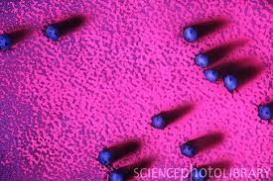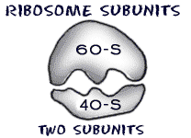
Lysosome | - Spherical sacs surrounded by a single layer of membrane.  - Contain powerful digestive enzymes. | - Protects the cell from enzymes contained within.  - Enzymes are used in the breakdown of materials e.g. cells taken up by white blood cells taken up in phagocytosis. | 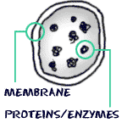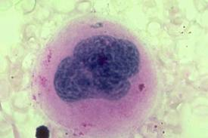
Vesicle | - Membrane bound sac | - Used to move substances around cells.
Plasma Membrane (Cell surface membrane) | - Present in all living cells  - Provides a selective barrier between the cells contents and the external environment | - Controlls the passage of substances into and out of the cell .  - Regulates the internal environment of the cell. | 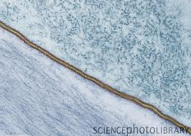
Mitochondria | - Spherical sausage shaped organelle formed from two membranes.  - The inner membrane is highly folded to form cristae. | - Site of aerobic respiration  - Produce adenosine triphosphate (ATP) | 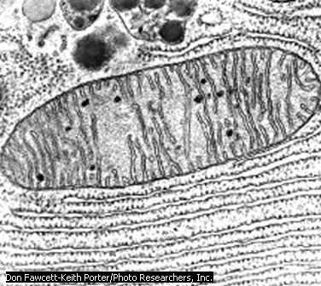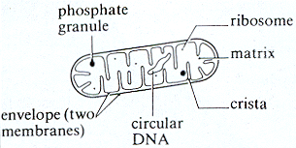
Chloroplast | - Found only in plant cells  - Two layers of membranes  - The inner layer is continuous and forms flattened membrane sacs called thylakoids. | - Site of photosynthesis a process in which Glucose is produced.  - Contain chlorophyll: a photosynthetic pigment. | 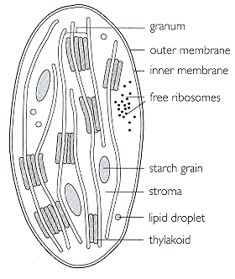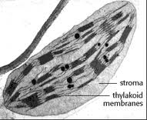
Cellulose cell wall | - On the outside of the plant cells plasma membrane. | - Supports the cell  - Helps maintain sell shape | 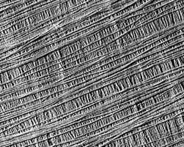
Centrioles | - Small tubes of protein fibres.  - There is a pair of them next to the nucleus in animal cells and some protocists. | - Take part in cell division.  - The spindle fibres used to move chromosomes grow from this organelle. | 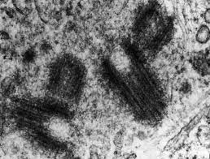
Vacuole | - A large membrane bound sac containing water and solutes.  - Found in plant cells | - Storage of water and solutes.  - Maintenance of cell turgidity. | 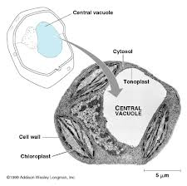

Animal cell
Nucleolus
Nuclear envelope with pores
Rough endoplasmic reticulum
Smooth endoplasmic reticulum
Mitochondrion
Golgi body
Vesicle
Lysosome
Centriole
Nucleus

Cell/plasma membrane

Plant cell
Nucleus
Nucleolus
Nuclear envelope with pores
Rough endoplasmic reticulum
Smooth endoplasmic reticulum
Mitochondrion
Golgi body
Chloroplast
Plasmodesmata
Cell wall
Central vacuole

Cell/plasma membrane

