Question: 1

(a) Fig. 3.1 is an electron micrograph of a chloroplast from a tobacco leaf.

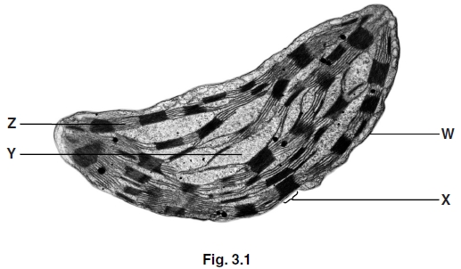(i) Identify the structures labelled W to Z.

W

X

Y

Z

[

(ii) In addition to the structures seen in Fig. 3.1, a chloroplast also contains DNA and ribosomes.

Suggest the role of DNA and ribosomes in this organelle.

_____________________________________________________________________________________________________

_____________________________________________________________________________________________________

_____________________________________________________________________________________________________

_____________________________________________________________________________________________________

_____________________________________________________________________________________________________

[

(b) The table below contains statements that refer to the light-dependent stage of photosynthesis.

Complete the table, indicating with the letters C, N or B, whether each statement applies to:

• cyclic photophosphorylation only (C)

or

• non-cyclic photophosphorylation only (N)

or

• both cyclic and non-cyclic photophosphorylation (B)

The first one has been completed for you.

[
statement | letter
ATP is produced | B
an electron leaves photosystem I

electrons are passed along an electron carrier chain

electrons leave both photosystem I and photosystem II

an electron from a water molecule replaces the electron lost from the photosystem

the same electron returns to the photosystem

[Total: 1

Question: 2

The molecules listed below are all associated with photosynthesis.

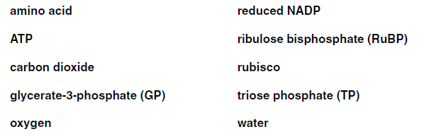From these molecules, identify:

(a) the enzyme.

[1]

(b) a product of the light-dependent reaction that is used in the light-independent reaction.

[1]

(c) a 3-carbon compound.
[1]

(d) a compound that can be made from TP but is not part of the Calvin cycle.

[1]

(e) a 5-carbon compound.

[1]

(f) a product of the light-dependent reaction that is not used in the light-independent reaction.

[1]
[Total: 6]

Question: 3

One way to determine the rate of photosynthesis is to measure the uptake of carbon dioxide.

(a) Discuss why measuring carbon dioxide uptake may or may not give a better indication of photosynthetic activity than measuring oxygen production.

_____________________________________________________________________________________________________

_____________________________________________________________________________________________________

_____________________________________________________________________________________________________

_____________________________________________________________________________________________________

_____________________________________________________________________________________________________

[2]

(b) Fig. 4.1 shows the relationship between light intensity and the relative carbon dioxide uptake and production in a plant.

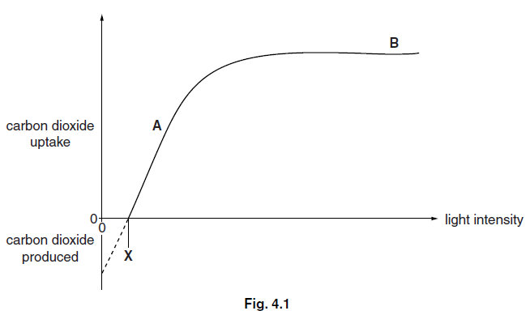(i) State the factor that is limiting the rate of photosynthesis at A on the graph.

[1]

(ii) Suggest one factor that may limit the rate of photosynthesis at B.

[1]
(iii) Carbon dioxide is given off by the plant when the light intensity is lower than X.

Name the process that produces carbon dioxide in the plant.

[1]

(iv) With reference to Fig. 4.1, explain the biochemical processes that are occurring in the plant:

• as light intensity increases from 0 (zero) to X.

• at light intensity X.

• at light intensities greater than X.

_____________________________________________________________________________________________________

_____________________________________________________________________________________________________

_____________________________________________________________________________________________________

_____________________________________________________________________________________________________

_____________________________________________________________________________________________________

[3]

(c) (i) Name the products of the light-dependent stage of photosynthesis.

_____________________________________________________________________________________________________

_____________________________________________________________________________________________________

_____________________________________________________________________________________________________

[3]

(ii) Paraquat is a weedkiller. It binds with electrons in photosystem I.

Suggest how paraquat results in the death of a plant.

_____________________________________________________________________________________________________

_____________________________________________________________________________________________________

_____________________________________________________________________________________________________

_____________________________________________________________________________________________________

_____________________________________________________________________________________________________

[2] [Total: 13]
Question: 4

(a) The Calvin cycle is the stage of photosynthesis during which carbon dioxide is fixed. The Calvin cycle uses the products of the light dependent stage.

(i) Name the products of the light dependent stage that are used in the Calvin cycle.

_____________________________________________________________________________________________________

_____________________________________________________________________________________________________

[2]

(ii) Discuss the fate of triose phosphate (TP) in the Calvin cycle.

_____________________________________________________________________________________________________

_____________________________________________________________________________________________________

_____________________________________________________________________________________________________

_____________________________________________________________________________________________________

_____________________________________________________________________________________________________

[3]

(b) A process known as photorespiration also takes place in photosynthetic cells. In this process, oxygen competes with carbon dioxide for the active site of the enzyme RuBP carboxylase (Rubisco).

Fig. 3.1 (a) and Fig. 3.1 (b) outline the processes of photosynthesis and photorespiration.

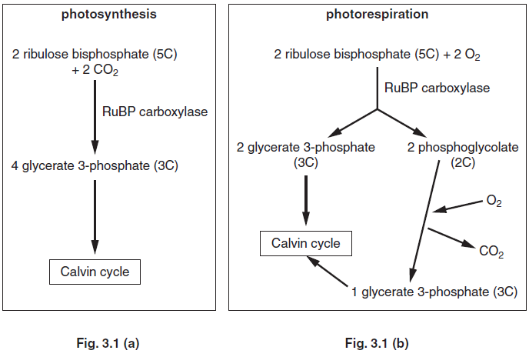(i) Suggest why the process outlined in Fig. 3.1 (b) is known as photorespiration.

_____________________________________________________________________________________________________

_____________________________________________________________________________________________________

_____________________________________________________________________________________________________

[2]

(ii) Using Fig. 3.1 (a) and Fig. 3.1 (b), describe and explain the likely effect on photosynthesis of an increase in the oxygen concentration.

_____________________________________________________________________________________________________

_____________________________________________________________________________________________________

_____________________________________________________________________________________________________

_____________________________________________________________________________________________________

_____________________________________________________________________________________________________

[3]

(iii) Some plants, known as C4 plants, use an enzyme called PEP carboxylase, instead of Rubisco, to fix carbon dioxide.

Suggest why these plants do not show photorespiration.

_____________________________________________________________________________________________________

_____________________________________________________________________________________________________

_____________________________________________________________________________________________________

[1] [Total: 11]

