OCR AS Biology : Unit 1 (F212) : Cells, exchange and transport.

Module 1 Cells – part 2: Membrane structure
We are learning to....... | Covered in Class | Revised | Understanding
Explain why plasma membranes are partially permeable barriers
What are the roles of membranes within cells
What are the roles of the membrane at the cell surface?
Describe, with the aid of diagrams, the fluid mosaic model of membrane structure.
Describe the role of the components of the cell membrane including cholesterol, glycolipid, proteins and glycoprotein.
Outline the effect of changing temperature on membrane structure and permeability.
Explain the term cell signaling
Explain the role of membrane-bound receptors as sites where hormones and drugs can bind.

Role / properties of membranes

Text book ref: p16-17
Key objectives:
- What are roles of membranes inside cells?
- What roles does the plasma membrane perform?
- Explain why plasma membranes are partially permeable barriers.

Questions: The role of membranes

The diagram shows some of the cell structures involved in the secretion of an extra cellular enzyme.
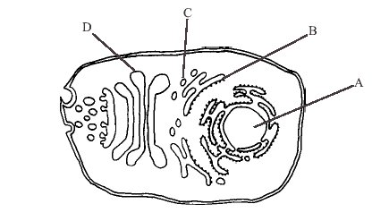
1) Identify structures A, B, C, and D [4]
A: ......................................... Nucleus B: .......... Rough endoplasmic reticulum
C: .................................……. Vesicle D: ....................Golgi apparatus

2) Give one structural similarity between the structure of A,B,C and D: [1]
All are membrane bound (OAW)

The diagram below shows the relationship between certain membrane bound organelles in a phagocytic cell.
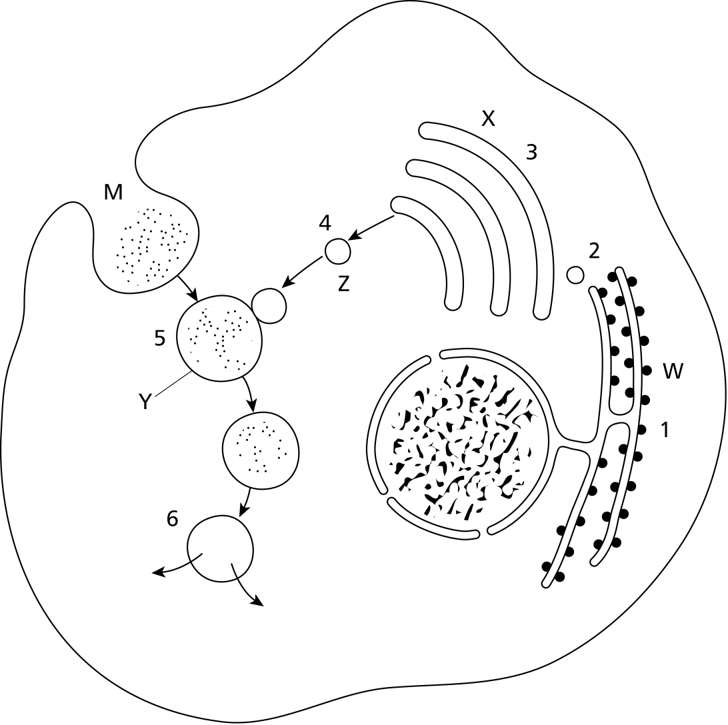

3) Name structures W-Z: [4]
Structure W Rough endoplasmic reticulum
Structure X Golgi apparatus
Structure Y Vesicle (Phagocytic vesicle)
Structure Z Vesicle (Golgi vesicle)
4) For each stage of the process (1-6) shown in the diagram above highlight the statement in each column which best describes the process: [6]

Stage 1 | Stage 2 | Stage 3 | Stage 4 | Stage 5 | Stage 6
Protein synthesis | Digestion | Diffusion | Protein modification | Transfer by vesicle | Pinocytosis
Protein modification | Diffusion | Protein synthesis | Transfer by vesicle | Digestion | Protein modification
Digestion | Protein modification | Transfer by vesicle | Transfer by vesicle |  | Protein synthesis
Transfer by vesicle | Transfer by vesicle | Protein modification | Endocytosis | Digestion | Diffusion

5) Substances M are being brought into the cell by: [1]
  - exocytosis and pinocytosis
  - exocytosis and phagocytosis
  - endocytosis and phagocytosis
  - endocytosis and pinocytosis
  - pinocytosis and phagocytosis

6) Complete the table below to describe the primary role of the membrane in the membrane bound organelles listed in the table below: [4]
Organelle | Structure / Feature | Role of membrane
Rough Endoplasmic reticulum | Rough Endoplasmic reticulum | One from:  - Hold ribosomes in place  - Form vesicles to separate protein products from the cytoplasm
Mitochondrion | Inner membrane folded into cristae | Holds the protein / enzymes in place required for aerobic respiration.
Lysosome | Vesicle containing hydrolytic enzymes. | Separate hydrolytic enzymes from the cytoplasm (preventing autolysis).
Nucleus | Nuclear envelope / nuclear pores | Control the movement of molecules into and out of the nucleus

7) State the 5 main roles of membranes within cells: [5]
- Separate organelles from the cytoplasm and from each other
- Allow diffusion, selective entry or exit of substances – such as oxygen into mitochondria, RNA but not DNA out from nucleus
- Give large surface area for reactions
- May hold electron carriers
- May hold enzymes
8) Explain why prokaryotic cells cannot store active hydrolytic enzymes within their cytoplasm. [3]
- No membrane bound organelles
- Hydrolytic enzymes contained within lyosomes in eukaryotic cells
- Enzymes are free within the cytoplasm of prokaryotic cells
- Active enzymes could not be prevented from hydrolysing internal structures

9) Explain what is meant by the term permeability [1]

- Explain why cell membranes are impermeable to most biological molecules. [4]
Most biological molecules are not lipid soluble or too large / to pass through the densly packed, hydrophic tail region.
Molecules which are polar/ have electrical charge (which means they would also be surrounded by water molecules) are unable to pass through the hydrophobic region.

Basic Membrane Structure

Text book ref: p16-19
Key objectives:
- How does the structure of phospholipids lead to creation of a bilayer
- Which components make up the fluid mosaic model
- How does structure of the plasma membrane relate to its function

Questions: phospholipids and bilayers

1) Distinguish between the terms hydrophilic and hydrophobic. [2]

Hydrophilic – “water loving”, molecules orientate towards water

Hydrophobic– “water hating”, molecules repelled by water

2) With the aid of a diagram if required describe the properties and structure of a phospholipid molecule. [6]

Head / phosphate group/ hydrophilic, polar, charged.

Tails/ 2 fatty acid, hydrocarbon/ hydrophilic, non-polar
3) What is the thickness of a cell surface membrane? [1]
7–10 nm

4) Explain why phospholipids align themselves into a bilayer at the interface between two watery areas such as the cell cytoplasm and the extracellular fluid. [4]

Phospholipid heads are polar and hydrophilic/ those of one lipid layer align themselves with heads in the watery cytoplasm/ and those of the other layer align with heads in the watery exterior/. The hydrophobic fatty acid tails are then tucked in the middle away from the watery cytoplasm and away from the watery exterior/.
5) Name a molecule able to pass directly through a cell membrane [1]
CO_{2,} O_{2,} H₂0, + any small non polar

6) Name a molecule that is unable to pass through a cell membrane [1]
any polar /large i.e. glucose, k⁺, Na²⁺

Questions: fluid mosaic model

The diagram below shows parts of a plasma membrane.
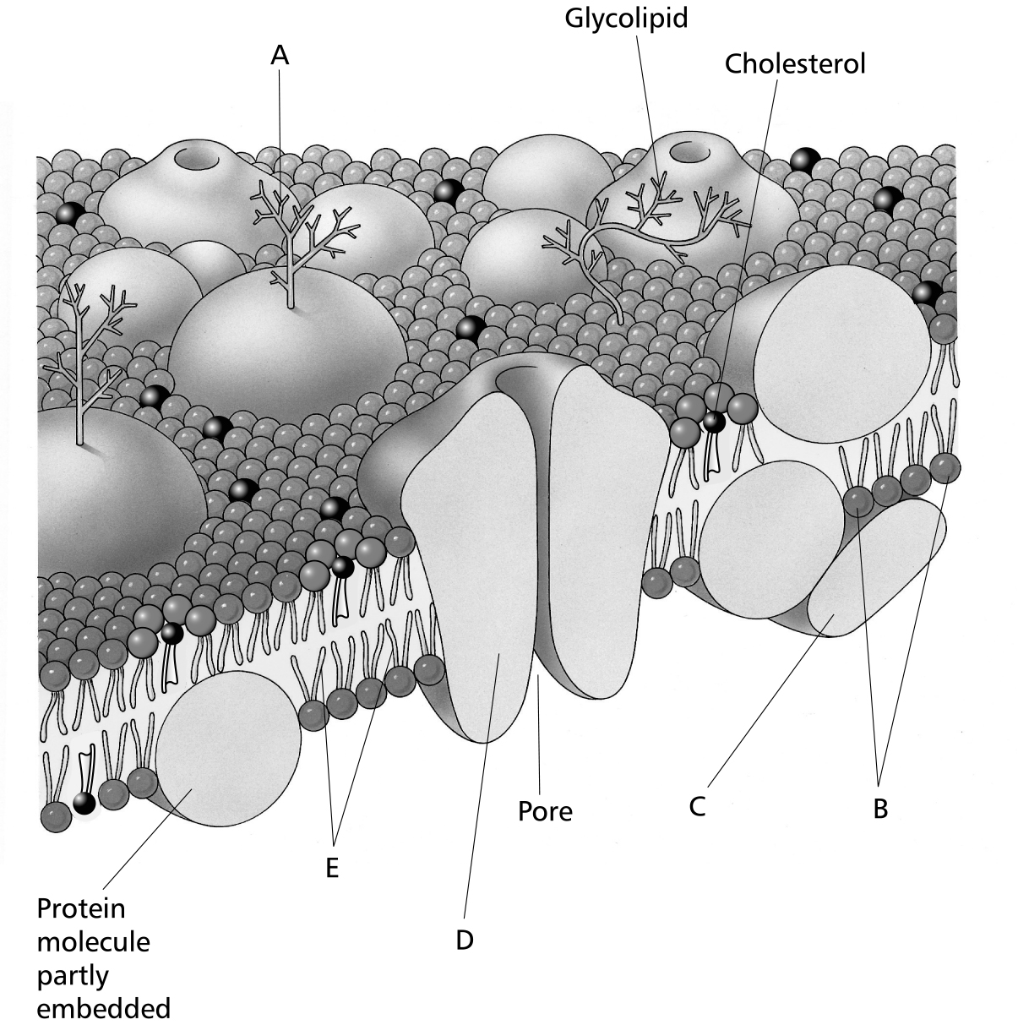

- Identify structures A–E. [5]
  - glycoprotein
  - polar (hydrophilic) heads of phospholipid molecules
  - peripheral protein
  - intrinsic protein
  - hydrophobic hydrocarbon tails of lipid bilayer
- Explain why the model of cell membrane structure shown in the diagram is called the fluid mosaic model. [2]
It resembles a mosaic, with protein molecules and lipids giving a mosaic appearance./ It is fluid as the proteins can move around./ The proteins float in a sea of lipid molecules.

- Is this cell membrane likely to be from an animal or plant cell? Give a reason for your answer. [2]
Animal / it contains cholesterol for strengthening. Animal cells need stronger membranes as they have no walls.

- Match the cell membrane components given below with their correct functions. [6]

Components | Functions
Intrinsic proteins  Extrinsic proteins  Cholesterol  Phospholipids  Glycolipids  Glycoproteins | Recognition sites for substances such as insulin and acetylcholine and act as antigens  Waterproofs membrane and makes it more rigid  Make membrane fluid, allow fat soluble molecules but not water soluble substances, to cross  Form channels or carriers for water soluble molecules  Act as enzymes  Make membrane stable and help cells attach to one another

Components | Functions
Intrinsic proteins  Extrinsic proteins  Cholesterol  Phospholipids  Glycolipids  Glycoproteins | D Form channels or carriers for water soluble molecules  E Act as enzymes  B Waterproofs membrane and makes it more rigid  C Make membrane fluid, allow fat soluble molecules but not water soluble substances, to cross  F Make membrane stable and help cells attach to one another  A Recognition sites for substances such as insulin and acetylcholine and act as antigens

- What is the difference between the structure of glycoproteins and glycolipids? [2]
Glycoprotein – hydrocarbon is attached to protein
Glycolipid - hydrocarbon is attached to lipid / phospholipid

The diagram below shows some of the components of the plasma membrane
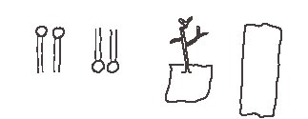
- Using the information shown and your own knowledge, draw a diagram to show the structure of the plasma membrane. [3]

Bi layer / transmembrane proteins/ glycoproteins all on one side and correctly orientated

- On your diagram label the components drawn and indicate the outer surface of the membrane. [4]
Phospholipid /glycoprotein / transmembrane protein / outersurface corresponds to glycoproteins.

- State two functions of the proteins in the plasma membrane. [2]
- Facilitate the movement of substances into or out of the cell
- Involved in metabolic processes (enzymes)
- Receptor sites for cell recognition and signaling

The diagram below shows the fluid mosaic model of the plasma membrane.

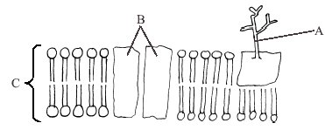

- Identify,

A. glycoprotein [1]

B. Channel protein [1]

C.Phospholipid bilayer [1]

- How do the properties of phospholipids ensure that the membrane remains fluid? [2]
Phospholipid molecules are not bonded to one another/ held in place by hydrophobic interactions/ free to move within the bilayer.

- Describe the purpose of cholesterol in plasma membranes [2]
  - Lies between the phospholipids prevents close packing
  - Therefore maintains fluidity and keeps the membrane stable
- Suggest why marine organisms living in polar regions have a very high proportion of cholesterol in their membranes [1]
  - Low temperatures reduce the kinetic energy of membrane components
  - At temperatures close to freezing cholesterol keeps the membrane fluid and functioning

Cell signaling and receptors

Text book ref: p20-21

Key objectives:
- What is meant by cell signalling?
- How do hormones and drugs bind to target cells?

Questions

- Name two components of the plasma membrane that can act as receptor sites for cell signalling / recognition: [2]
  - Glycoproteins / glycolipids
  - Proteins held by the membrane

- Suggest why glycolipids are only found on the outside surface of the plasma membrane [2]
  - Associated with cell recognition
  - Interact with transmitter substances outside of the cell
  - If they were located inside of the cell the messenger would have to cross the membrane before binding with them.
  - Many transmitters including non sterol hormones care unable to cross the plasma membrane

The diagram shows part of the cell-surface membrane of a cell from the small intestine. Molecule Y acts as a cell-surface receptor for growth hormone.

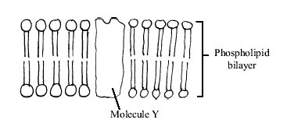
3) State the likely nature of molecule Y. [1]

Protein

4)State the approximate length of molecule Y. [1]

7–10 nm
5) Explain why molecule Y is only able to recognize growth hormone. [1]

Receptor site on the protein has a complimentary shape to the hormone molecule therefore it is only able to bind to that specific hormone.

6) Suggest why pygmies are unable to achieve normal growth despite producing abnormal amounts of growth hormone. [1]

- Low number of receptor proteins in membrane/
- Receptor proteins incorrectly shaped so they are unable to bind as effectivelywith the hormone.
7) Define the term cell signaling [2] Cells communicate with each other by signals./ many molecules act as signals some signal during processes taking place inside cells; other signal from one cell to others./ named example e.g. cytokines, hormone

Test yourself on what you should know.

Answer the following questions on a separate piece of paper

- How thick is the Cell Surface Membrane of a Eukaryotic Cell?
- What type of molecule constitutes the head of a Phospholipid?
- What is the Biological term for being “attracted to water”
- What is the Biological term for being “repelled be water”
- What are the tails of a phospholipid molecule made of?
- How many tails are there on a phospholipid molecule?
- Is the cell surface membrane freely permeable or partially permeable?
- How many layers of phospholipids are there in the cell surface membrane?
- What is the Glycocalyx?
- What is a Glycoprotein?
- What does cholesterol do in the cell surface membrane?

