Cell structure
The cell is the basic unit of structure in living organisms. Structures within a cell with a specific function are called ORGANELLES.
Cell membrane
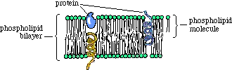
Structure: The cell surface membrane is made up of two layers of phospholipids and is embedded with proteins, such as receptors on the outer surface.
Function: The cell membrane separates the contents of the cell from its external environment and regulates the movement of substances in to and out of the cell. Most organelles inside the cell are surrounded by their own membrane, enabling separate compartments to be formed where specialised reactions take place e.g. mitochondria

Nucleus
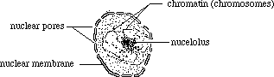
Structure: The nucleus is a large, round organelle surrounded by a double membrane, called the nuclear envelope. The nuclear envelope contains large nuclear pores to allow the exchange of materials between the nucleus and the cytoplasm. DNA is found in the nucleus and the nucleus also contains a dark staining region called the nucleolus, which produces ribosomes.
Function: The nucleus contains the cell’s DNA and controls all the activities of the cell.

Mitochondrion (plural: mitochondria)
Structure: Mitochondria are oval in shape and have a double membrane. The inner membrane of the mitochondrion is highly folded in to cristae, which increases surface area. The matrix is a viscous liquid which contains enzymes.
Function: Some of the reactions of aerobic respiration occur in the mitochondria and they are the “power houses” of the cell, producing energy in the form of ATP.

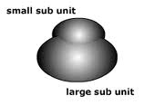
Ribosomes Structure: Ribosomes consist of two subunits, one large and one small.
The subunits are made up of protein and ribosomal RNA. They can be found floating free or attached to the endoplasmic reticulum.
Function: Ribosomes are the site of protein synthesis.

Endoplasmic reticulum (ER)
Structure: A large network of membranes. There are two types, the rough endoplasmic reticulum (RER), which is covered with ribosomes, and the smooth endoplasmic reticulum (SER), which does not have ribosomes.
Function: 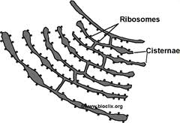
- Rough endoplasmic reticulum - Transports the proteins synthesised at the ribosomes
- Smooth endoplasmic reticulum- Produces and transports lipids

Golgi apparatus (also known as Golgi body)
Structure: A stack of flattened, membrane bound sacks (like a stack of pancakes) with smaller vesicles around it

Function:
- Transports and chemically modifies the substances in it e.g. proteins
- Produces lysosomes
- Cells involved with secretion contain large amounts of Golgi apparatus e.g. cells of the pancreas which secrete digestive enzymes

Lysosome
Structure: A sac consisting of a single membrane which contains digestive enzymes. The enzymes have to be kept apart from the rest of the cell or they would destroy it. The contents are acidic and the enzymes have a low optimum pH.
Function: The lysosome breaks down unwanted molecules and structures inside the cell.
THE FOLLOWING STRUCTURES ARE FOUND IN PLANT CELLS ONLY
Cell wall
Structure: A rigid layer that surrounds the cell membrane, made of cellulose.
Function: The cell wall provides support for the plant and stops the cell bursting if it is exposed to a dilute solution. It is fully permeable though, enabling water and other substances to pass through it.

Chloroplast
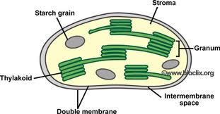
Structure: Chloroplasts have a double membrane The inner membranes of chloroplasts are called thylakoids, which is where one of the reactions of photosynthesis takes place. The thylakoids often form coin-like stacks called grana (singular granum). Chloroplasts are green as they containg the pigment chlorophyll.
Function: Photosynthesis takes place in the chloroplast.

Vacuole
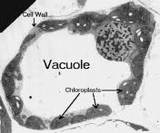
Structure: A large sac in the cytoplasm, surrounded by a single membrane which contains a fluid called cell sap. Cell sap is water with dissolved substances, such as minerals and ions.
Function: The vacuole is important in maintaining the cell in a turgid state, which provides support to the plant.

